LIBRARY AUTOMATION SYSTEM

CONTENTS

SERIAL NO. | TOPIC | PAGE NO.
1 | Problem definition, Objectives, Preliminary ideas | 3
2 | Feasibility study, Requirement analysis and specification | 4
3 | Entity relationship diagram and Database design | 4
4 | Context Diagram and Data flow diagram | 8
5 | Coding | 11
6 | Conclusion | 23

The Project:
Library Automation System.
The Problem:
A city library in Kolkata planned to automate its’ library operations and member operations.

Library lends books, CDs and DVDs to its’ members. Library administrator should be able to add a book/CD/DVD with book/CD/DVD name, author name, category (Fiction, Entertainment, Technical, and Management etc.), number of copies.

Member should be registered with library before he is allowed to check out book/CD/DVD. Member needs to give name, date of birth, sex, address, contact number and gets a member id. Member id needs to be specified for any transactions to be done in library.

Search facility needs to be made available to members by book name or author name or category or combination of above to search the relevant resources.

Member can choose one or more book/CD/DVD to check out. Software needs to ensure the availability of the book before check out. Due date needs to be displayed once checked out. Due dates are 10 days, 5 days and 3 days for book, CD and DVD respectively. Member also should be able to see the list of books that she/he checked out. Also should be able to return the book that he/she checked out. When the member returns the book beyond the due date, he/she should be fined accordingly. Fines are Rs. 1/-, Rs. 2/- and Rs. 3/- for book, CD and DVD respectively.

Administrator should be able to see the list of books checked out or due or returned for a given date.

Objectives:
- Library Administrator can add new resources to the library.
- People can become new member of the library.
- Only members can borrow resources from the library.
- Members can search resources by book name or author name or category or combination of these.
- Member can choose one or more book/CD/DVD to check out. Software needs to ensure the availability of the book before check out.
- Due date needs to be displayed once checked out.
- Member also should be able to see the list of books that she/he checked out.
- Also should be able to return the book that he/she checked out. When the member returns the book beyond the due date, he/she should be fined accordingly.

Preliminary Ideas:

- The library administration system is designed to cater to the needs of the library administrator and the members of the library.
- This web based application can be used by the library administrator to add records of the resources and check the details of the resources that are borrowed and returned on a particular date.
- This application is also built keeping in mind the needs of the members of the library. The library administrator on behalf of the members can search particular resources and provide them to the members. Apart from this he can also provide membership to the new customers visiting the library and provide them a member id. The administrator can inform the members of the number of resources borrowed by them and if any fine is due from them.
The Feasibility Study:

As the initial investigation is completed, it leads to a more detailed investigation of the system. The conclusions of the initial study become the input for the detailed study. We can also refer to the feasibility study as the detailed study or detailed investigation. Feasibility study is called like because as in the first phase, we just check briefly about the problems related to the old system, & the need of the new system. So, in this phase, that initial survey is further expanded to a more detailed feasibility study.

The tasks performed during this phase were as follows:

(a) The user’s demonstrable needs are fulfilled.
(b) The availability of resources was being checked.
(c) The estimation required for the resources were achieved.
(d) The impact of the system on the organization has been check by placing a model in it.

Requirement Analysis and Specification:

Objective To Be Fulfilled:

(a) Development of software in the given time.
(b) To create an effective and efficient application.

User Requirements:

(a) The application should provide a user friendly environment.
(b) The application should be easily understandable and reliable.
(c) The application should fulfill all essential facilities.
(d) The software being built must provide platform independent application.

Requirement Determination Techniques & System Analysis Method:

(a) User communication
(b) Team discussion
(c) Analysis of existing system
(d) Study of old projects and records.

Design – High level and Low level

Entity Relationship Diagram:

Conceptual modeling is a very important part in designing a proper database application. Here the term database application refers to a software product that has a central database containing data and some associated programs that operate on the data in the database to give desired results of our queries. In the Library Automation System problem we are representing conceptual model of the problem by the help of ER data modeling. An entity-relationship (ER) diagram is a specialized graphical representation that illustrates the interrelationships between entities in a database. ER diagrams often use symbols to represent three different types of information. Boxes are commonly used to represent entities. Diamonds are normally used to represent relationships and ovals are used to represent attributes.

For our database application consider a LIBRARY AUTOMATION database that keeps track of all the books, CD’s and DVD’s in the library, along with that the LIBRARY AUTOMATION database also keeps details about the members of the library such as the name, date of birth, sex, address, contact number etc. The LIBRARY AUTOMATION database also keeps record of the resources of the library that has been lent to the various members of the library.
In our LIBRARY AUTOMATION database there are three entities namely: MEMBER, RESOURCE, and CHECKOUT.
- MEMBER: This entity keeps record of all the members of the Library. Speaking in details this entity keeps the basic details about the members such as their name, gender, address, contact number, date of birth. The attributes of this entity are [NAME],[SEX],[DOB],[ADDRESS],[CONTACT_NO],[MEMBER_ID].
- RESOURCE: This entity keeps information about the basic resources of the library which are books , CD’s and DVD’s. Each record in this entity is made up of all the information needed to categorize any resource in the library, starting with the name of the resource ,the resource id(a unique number to identify each instance of the resource separately), the category of the resource (i.e. Fiction, Entertainment, Technical, and Management etc.) ,the resource type(i.e. paperback, hard back, CD,DVD etc.), the name of the author or publisher or owner, the number of copies of that particular resource available in the library, whether it is still available or all the copies of that particular resource has been taken by members. The attributes of this entity are [RESOURCE_ID],[NAME],[TYPE],[AUTHOR_NAME],[CATAGORY],[NO_OF_COPIES],[AVAILABLE].
- CHECKOUT: This entity keeps the vital information about the resources borrowed by the members of the library. It keeps information about the member who has borrowed a resource , the resource that has been borrowed, date it has been borrowed on ,date it must be returned. The attributes of this entity are [C_ID],[MEMBER],[RESOURCE],[BORROW_DT],[RETURN_DT].
Now the above three entities are related to each other by the following relationships:
- MAKES: The entities MEMBER and CHECHOUT are related by MAKES relationship. We know that when a member borrows a book, the relevant information is stored in CHECHOUT relation. As one member can borrow many books the relation MAKES is a 1: N relation.
- TAKEN: The entities CHECKOUT and TAKEN are related by TAKEN relationship. The significance of TAKEN relation is that there are several copies of each resource in the library, thus different instance of the same resource can be borrowed by different members at the same time, thus the relation TAKEN is 1: M relation.

Entity Relationship Diagram:
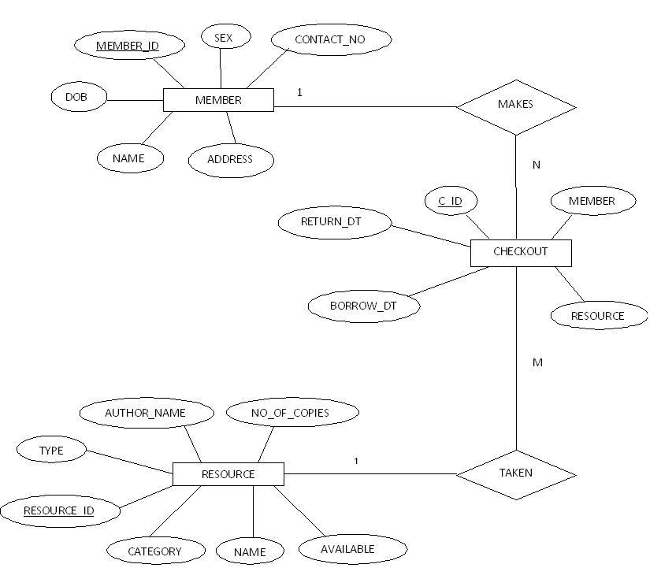

DATABASE DESIGN:

Relational schemas and functional dependencies:

- MEMBER(MEMBER_ID, NAME, ADDRESS,DOB, SEX, CONTACT_NO)

This table contains the details about the members of the library system. The table consists of Name of the member [NAME], Gender [SEX], Date of Birth [DOB],Address of the member [ADDRESS],Contact number of the member [CONTACT_NO],unique id for eacf member [MEMBER_ID]. Here in this table the Primary key is [MEMBER_ID].

This table has the following Functional Dependencies:

- MEMBER_ID -------> { NAME , SEX , DOB , ADDRESS , CONTACT_NO }

- CHECKOUT(C_ID, MEMBER, RESOURCE, BORROW_DT, RETURN_DT)

This table contains the details of the resources that have been lent to the members. This table consists of checkout id [C_ID], member id [MEMBER_ID], resource id [RESOURCE_ID], borrow date [BORROW_DT], and return date [RETURN_DT]. Here the primary key is [C_ID].

This table has the following Functional Dependencies:

- C_ID → { BORROW_DT, DUE_DT, RETURN_DT }

- RESOURCES(RESOURCE_ID, NAME, TYPE, AUTHOR_NAME, CATEGORY,NO_OF_COPIES,AVAILABLE)

This table contains the details of the resources that form the collection of the library. This table consists of the resource id [RESOURCE_ID], name of the resource [NAME], the resource type [TYPE], the name of the author or publisher or owner [AUTHOR_NAME], the category of the resource [CATEGORY], availability info [AVAILABLE], number of copies of that particular resource [NO_OF_COPIES].

This table has the following Functional Dependencies:

- RESOURCE_ID → { NAME, TYPE, AUTHOR_NAME, CATEGORY,NO_OF_COPIES,AVAILABLE }

CONTEXT DIAGRAM

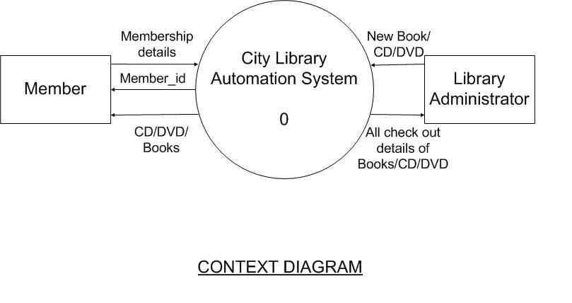

The Context diagram represents the entire system as a single module. The data values that are given to the system comprises of three types.

First of all the new resources (books, CD’s, DVD’s) may be added to the system which the library administrator does and also the library administrator can check out the details about all the resources in the system.

Secondly, a person may want to borrow resources from the library. For that he/she has to become a member of the library. Thus the person becomes a member by submitting his/her personal details to the system; in return the system assigns the person a unique Member_id.

Thirdly, a member may want to borrow a particular resource from the library. The member submits the resource description and checks if that resource is available. If the resource is available then the member’s member id is taken and a instance of the resource is allotted in his name. If the resource is not available the member is informed of it. Apart from this the system also shows the details of all resources present in the database.

DATA FLOW DIAGRAM

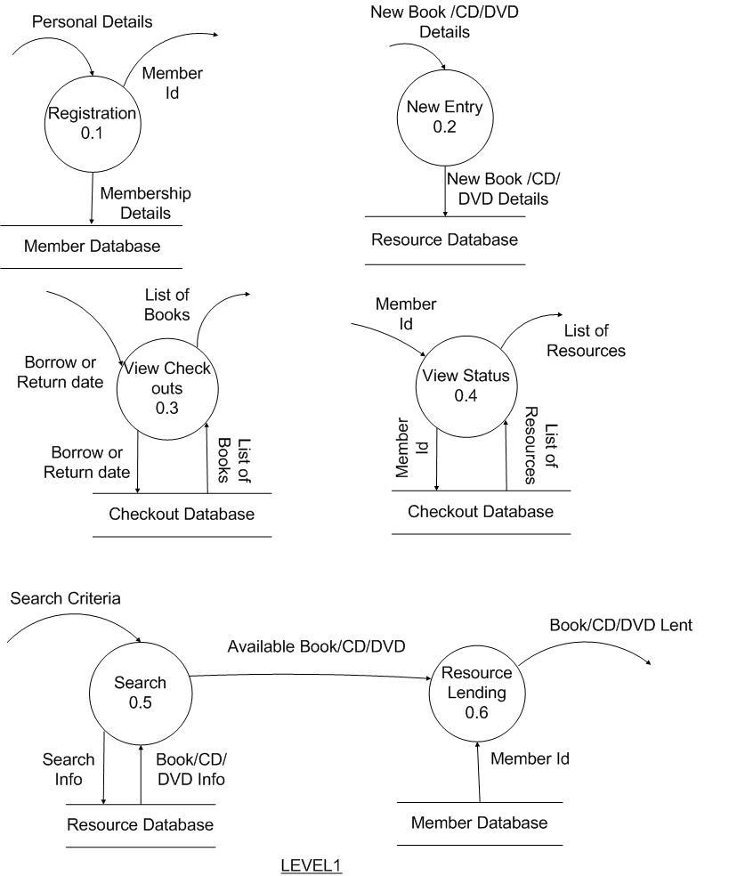
The Level 1 of the Data Flow Diagram shows Context diagram broken down into six modules:

The Registration module takes the personal details about a person who wants to become a member of the library inserts the details in the member database and assigns the person a member_id. The New Entry module takes in as input details of new resources that are added to the collection of the library by the library administrator, it inserts the details in the resource database. The view checkouts module takes in as input Borrow date or Due date or Return date, matches the inputs against the checkout database and shows the matching results, this module is mainly used to see the list of books that are currently with the members and various details like when and by whom it was borrowed or when it should be returned etc. The View Status module is used by the members to check out the resources borrowed by them and the total fine amount (if any) due from them for not returning resources on time. The Search 0.5 module takes in as input the search criteria from the members and matches those criteria against the resource database, if any resource is found matching that criteria, then again with that information it is checked if it is available. If it is available then that information is passed to the Resource Lending module as input. The Resource Lending module takes the member_id from the member database and does the needful to lend the resource to that member.

CODING
The Coding part comprises of designing ‘html web pages’ and writing appropriate codes to serve the purpose. For each of the designed web pages we have a java servlet file written which include the code to connect with the database and serve the purpose of the web page. The database used here is Oracle. The code snippets of the designed web pages are given as follows.
MEMBER REGISTRATION
The member registration page is used to get the details of the members who want to make a membership in the library. The page is used to accept the member details which are the stored in the database.
The member registration page is shown below:
Figure 1: Member Registration Page
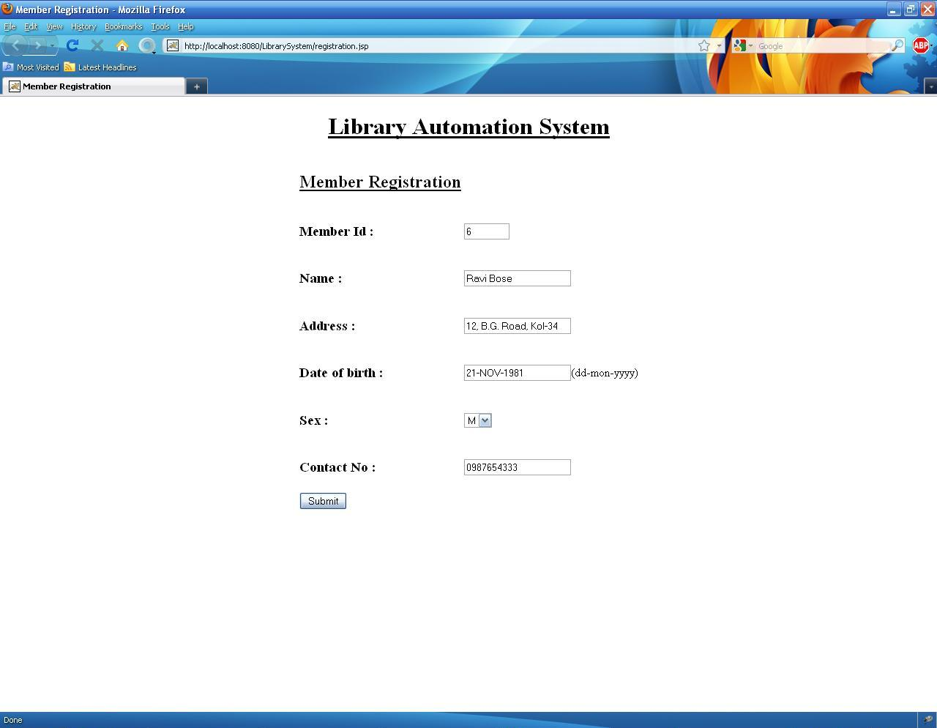

CODE SNIPPETS:
As mentioned earlier the code part of the page is contained in a separate java servlet page. Here the connection with the database is made and the values are inserted into the database. The connection with the database is done as follows:
Class.forName ("com.mysql.jdbc.Driver");
con=DriverManager.getConnection("jdbc:mysql://localhost:3306/DBName","Root","Password”);

Here con is a connection object. The username and password should be given by the user accordingly. The database name referred here as dbname should also be specified. The values mentioned in the textboxes of the webpage are assigned to local variables with similar names to get the values in them as shown:
String memid= request.getParameter("memid").toString();
String name = request.getParameter("memname").toString();
String address = request.getParameter("add").toString();
String dob= request.getParameter("dob").toString();
String sex= request.getParameter("sex").toString();
String contact= request.getParameter("contact").toString();
Then the connection with the database is made and a statement object is created and the query is executed to insert the values into the database. The following code is used to do it:
s1 = con.createStatement();
String s="insert into member values('"+ memid +"','"+name+"','"+address+"','"+dob+"','"+sex+"','"+contact+"')";
n=s1.executeUpdate(s);
Here s1 is the statement object and the string‘s’ is used to create the complete query which is then executed. Here n is a local integer variable. A suitable report is then given to the user to inform whether the record was successfully inserted or an error occurred while executing the statement.

SERCH RESOURCES AND SELECT THEM
The search resource page is used by the members of the library to search the resources present in the library. Here the resources are Books or CD or DVD. The members are provided with different search criteria. They can use either one of the search criteria or any combination of them. The search criteria are Book name, Author name and Category.
The search resources page is shown as follows:
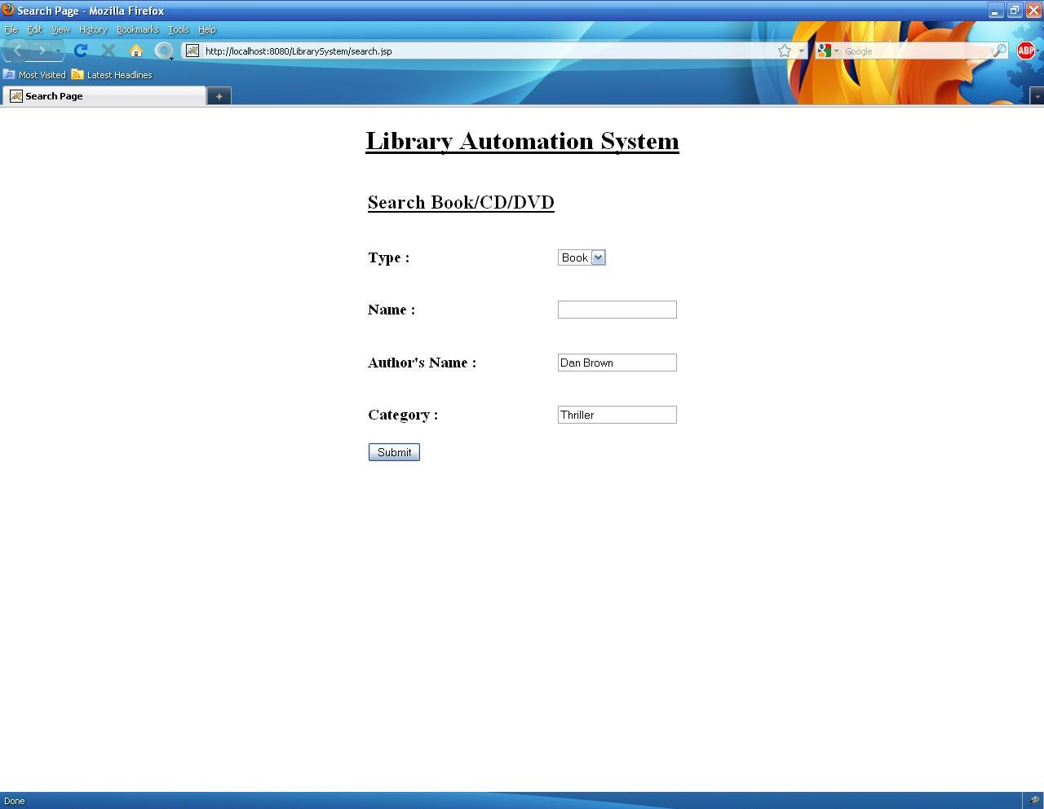
Figure 2: Search Resources Page

CODE SNIPPETS:
In the servlet file corresponding to this page we create a query statement to which the search criteria are appended if they are given to finally create the complete query statement which can be executed to produce the desired result. But first as mentioned earlier we make a connection with the database as :
Class.forName ("com.mysql.jdbc.Driver ");
con=DriverManager.getConnection("jdbc:mysql://localhost:3306/DBName","Root","Password”);
Here con is a connection object. The username and password should be given by the user accordingly. The database name referred here as dbname should also be specified. The values mentioned in the textboxes of the webpage are assigned to local variables with similar names to get the values in them as shown:
String type= request.getParameter("type").toString();
String name = request.getParameter("name").toString();
String author = request.getParameter("author").toString();
String category= request.getParameter("category").toString();
Then the connection with the database is made and a query statement is made by checking whether at least one of the search criteria is given or not. The code for this is shown below:
s1 = con.createStatement();
String s=”select * from resource where type=’”+type+”’”;
if(!name.isempty())
{
s=s+”and name=’”+name+”’”;
}
if(!author.isempty())
{
s=s+”and authorname=’”+author+”’”;
}
if(!category.isempty())
{
s=s+”and category=’”+category+”’”;
}
Resultset records;
records =s1.executeQuery(s);

Here s1 is the statement object and the string‘s’ is used to create the complete query which is then executed. Here ‘records’ is a Resultset Object used to display the records. The records are displayed by creating an html page in which the records are displayed in proper format by placing them as done while creating a normal html page. While displaying the resources we check if it is available. If it is available then only it is displayed. Else a suitable message is given to the user in case of an unsuccessful search. In that web page we also provide an option to select the resource which the user wants to check out. An entry corresponding to that check out is made in the database. The resource selection page is shown as follows.
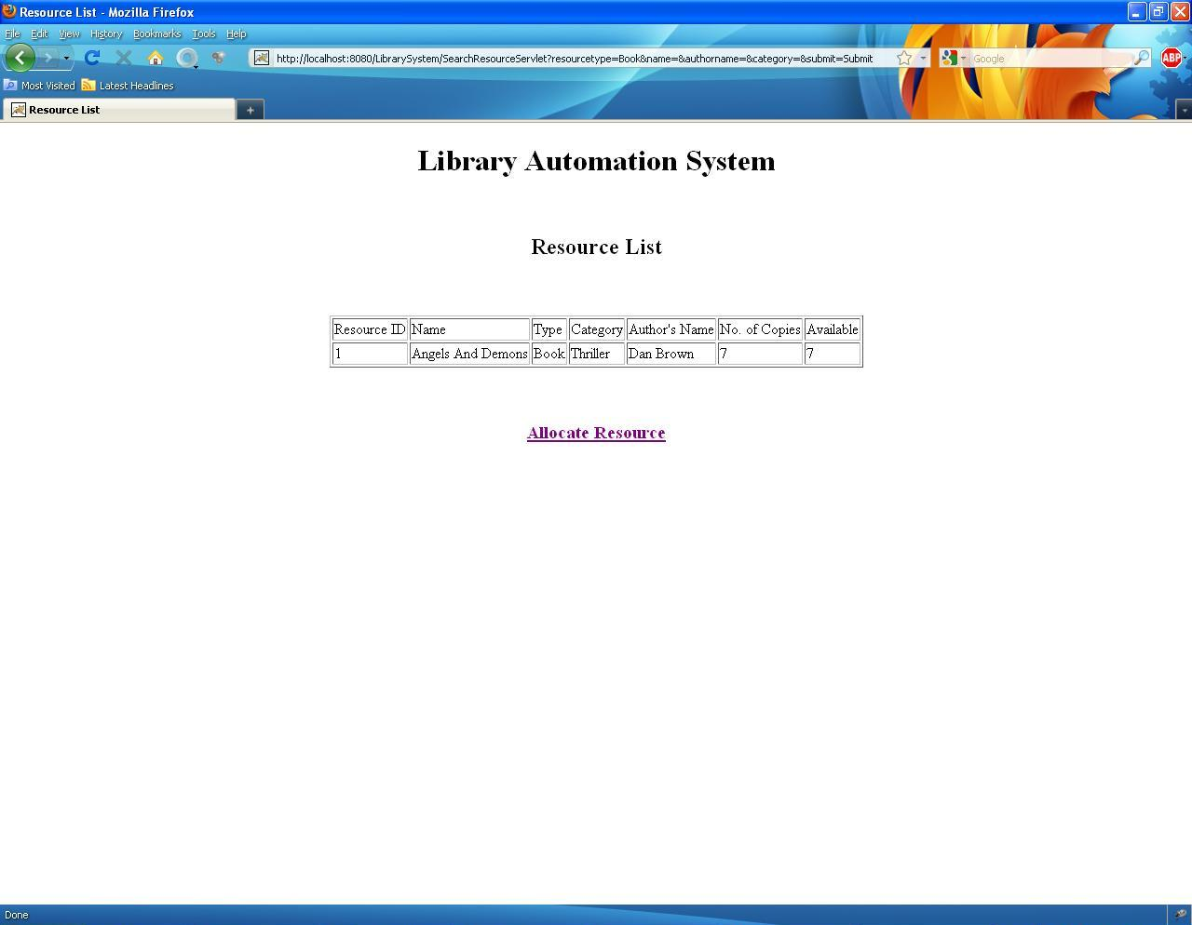
Figure 3: The Resource Selection Page
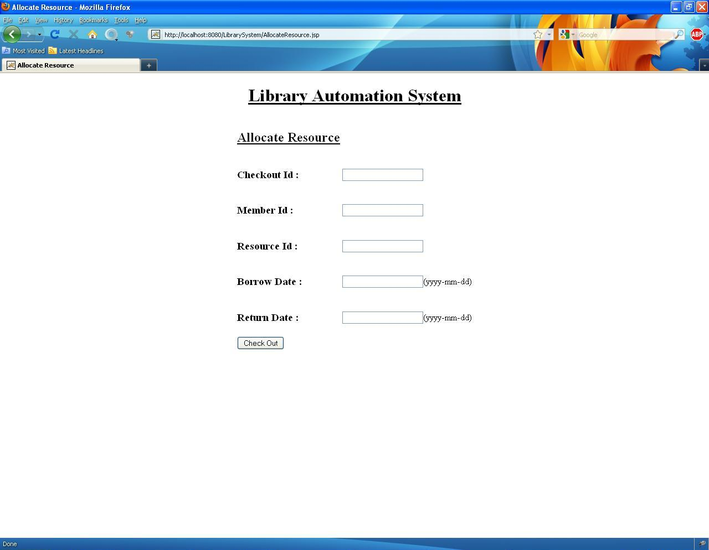
Figure 4: Check Out Resource Page
In the Resource selection page we select a resource and a record of it is made in the database. The following code gives an idea of how this is carried out.
CODE SNIPPETS:
In the servlet corresponding to the Resource Selection Page we make an entry in the database corresponding to the resource that the user has selected. As mentioned earlier in this case as well we make a connection with the database as shown.
Class.forName ("com.mysql.jdbc.Driver");
con=DriverManager.getConnection("jdbc:mysql://localhost:3306/DBName","Root","Password”);

Here con is a connection object. The username and password should be given by the user accordingly. The database name referred here as dbname should also be specified. The values mentioned in the textboxes of the webpage are assigned to local variables with similar names to get the values in them as shown:
String cid= request.getParameter("cid").toString();
String member = request.getParameter("member").toString();
String resource = request.getParameter("resource").toString();
String borrow_dt= request.getParameter("borrow_dt").toString();
String return_dt= request.getParameter("return_dt").toString();
Then the connection with the database is made and a statement object is created and the query is executed to insert the values into the database. The following code is used to do it:
s1 = con.createStatement();
String s="insert into checkout values('"+ cid +"','"+member+"','"+resource+"','"+borrow_dt+"','"+return_dt+"')";
n=s1.executeUpdate(s);
In the above code s1 is the statement object and the string‘s’ is used to create the complete query which is then executed. Here n is a local integer variable. A suitable report is then given to the user to inform whether the record was successfully inserted or an error occurred while executing the statement. At the same time when a record is made for a particular check out an update query is executed to update the availability status of the recently selected resource in the resource database. The code for it is shown as follows.
s1 = con.createStatement();
String s2="select available from resource where resource_id=’”+resource+”’”;
Resultset r1=s1.executeQuery(s2);
int n2;
s1 = con.createStatement();
String s3=”update resource set available=”+(r1.getInt("available")-1)+”where resource_id=’”+resource+”’”;
n2=s4.executeUpdate(s3);
In the above code s1is a statement object and the string‘s2’ and’s3’ is used to create the complete query which is then executed. Here n2 is a local integer variable.
VIEW STATUS
The view status page is used to view the status of a member which means the number of resources he or she had taken and their corresponding return dates. It also includes any fine which they are supposed to pay in case they do not return the resources on time. The page is shown below whose output is given in a different page.

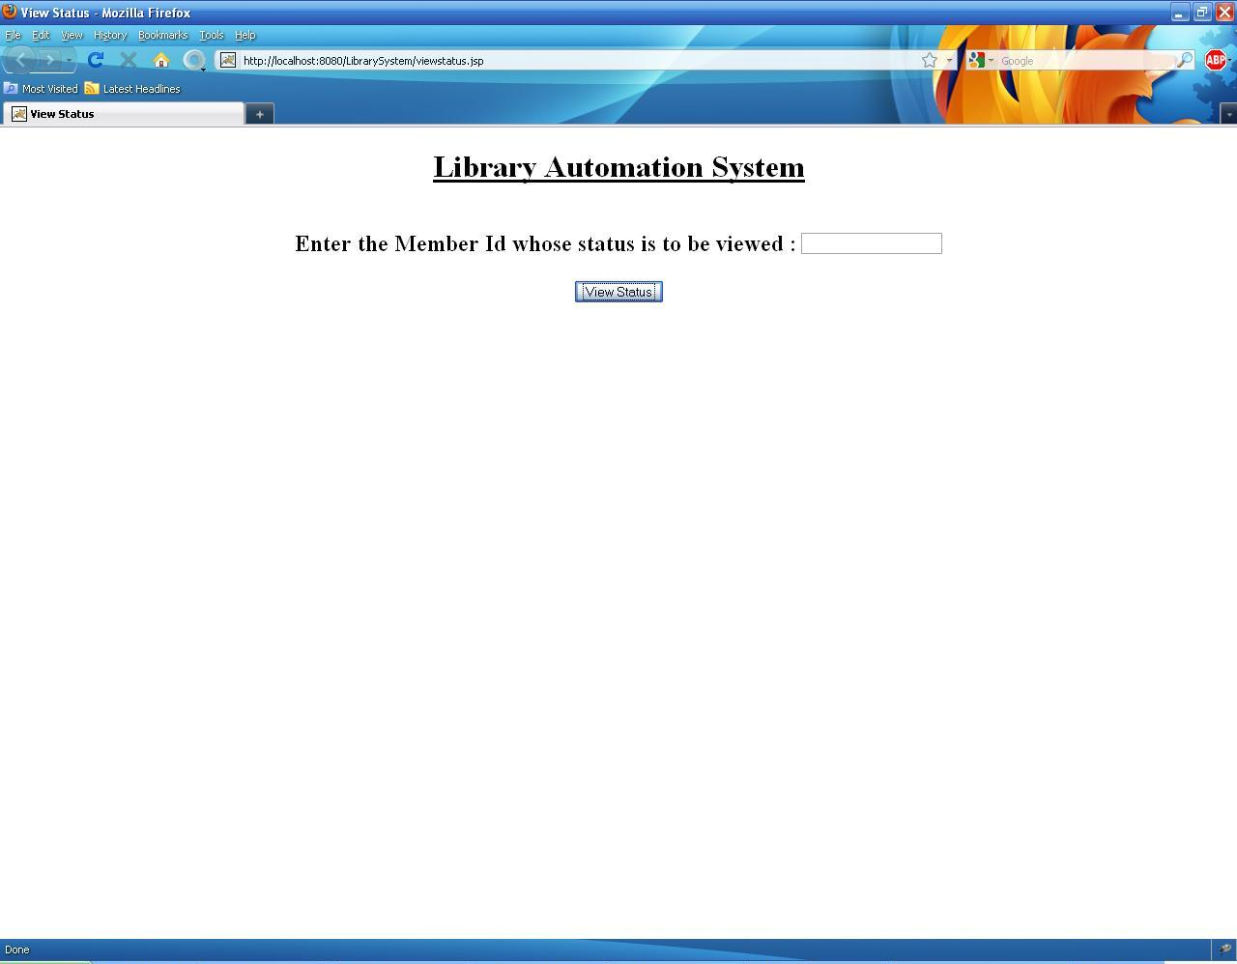
Figure 5: View Status
CODE SNIPPETS:
In the servlet of the view status page the list of resources borrowed by the member is shown. If the member has not borrowed anything then an appropriate message is shown. For this purpose all the entries of the checked out resources is seen and the list is generated to inform the member. Here also we make a connection with the database as shown.
Class.forName ("com.mysql.jdbc.Driver");
con=DriverManager.getConnection("jdbc:mysql://localhost:3306/DBName","Root","Password”);
Here con is a connection object. The username and password should be given by the user accordingly. The database name referred here as dbname should also be specified. The value mentioned in the textbox of the webpage is assigned to local variables with similar names to get the value in them as shown:
String memid= request.getParameter("memid").toString();
Then the connection is made with the database and a query statement is build and executed to serve the purpose. The code for it is shown :
s1 = con.createStatement();
String s="select * from checkout where member=’"+memid”’”;
records =s1.executeQuery(s);
Here s1 is the statement object and the string‘s’ is used to create the complete query which is then executed. Here n is a local integer variable. Here ‘records’ is a Resultset object to display the records. In this case the records are displayed in a separate web page.
In this webpage we also mention if any fine is to be paid by that member. The code for it is shown as follows:
s1 = con.createStatement();
String s="select return_dt,type from checkout,resource where checkout.resource=resource.resource_id and member=’"+memid”’”;
records =s1.executeQuery(s);
String s2=”select to_date(sysdate)-to_date(‘records.getDate(“return_dt”)’) as datediff from dual”;
records2=s1. executeQuery(s2);
int fine;
if(records2.getInt(“datediff”)>0)
{
String type= records.getString(“type”);
if( type.matches(“Book”))
fine= records2.getInt(“datediff”)*1;
if(type.matches(“CD”))
fine= records2.getInt(“datediff”)*2;
if(type.matches(“DVD”))
fine= records2.getInt(“datediff”)*3;
}
else
fine=0;

Then we display the fine in a text box as shown later. Here records and records2 are Resultset objects and s1 is a statement object. The resultant web page is shown as:
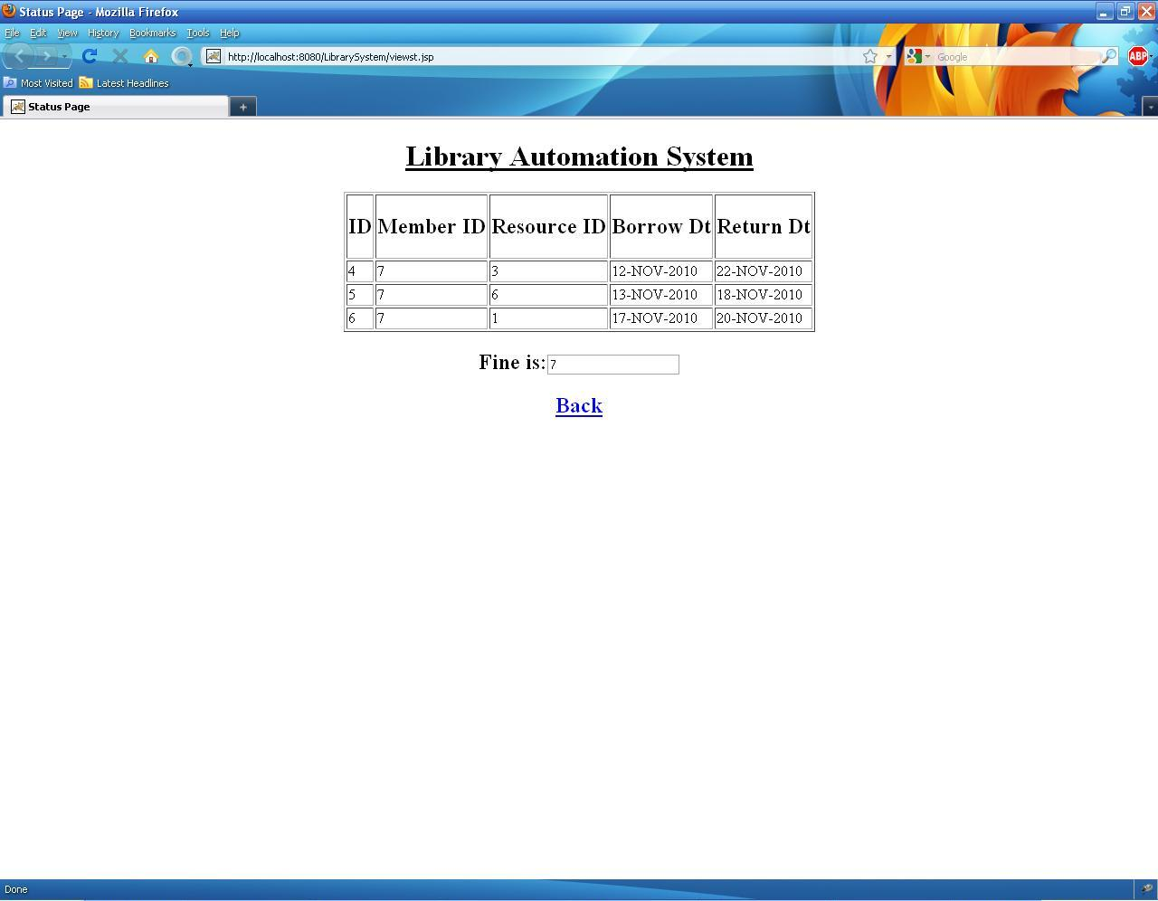
Figure 6: View Status Result Page

Thus the status of a particular member is shown.
ADD RESOURCE
In the add resource page the library administrator adds new resources to the library. This is done by inserting a record into the database corresponding to the new item that is added to the library. The add resource page is shown as follows.
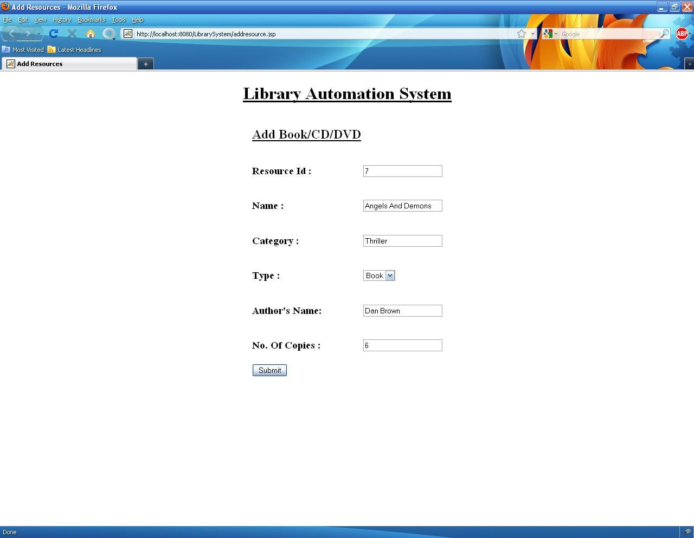
Figure 7: Add Resource Page
CODE SNIPPETS:
As mentioned earlier the code part of the page is contained in a separate java servlet page. Here the connection with the database is made and the values are inserted into the database. The connection with the database is done as follows:
Class.forName ("com.mysql.jdbc.Driver");
con=DriverManager.getConnection("jdbc:mysql://localhost:3306/DBName","Root","Password”);
Here con is a connection object. The username and password should be given by the user accordingly. The database name referred here as dbname should also be specified. The values mentioned in the textboxes of the webpage are assigned to local variables with similar names to get the values in them as shown:
String resourceid= request.getParameter("resourceid").toString();
String name = request.getParameter("resourcename").toString();
String category = request.getParameter("category").toString();
String type= request.getParameter("type").toString();
String author= request.getParameter("author").toString();
String no_of_copies= request.getParameter("no_of_copies").toString();
Then the connection with the database is made and a statement object is created and the query is executed to insert the values into the database. The following code is used to do it:
s1 = con.createStatement();
String s="insert into resource values('"+ resourceid +"','"+name+"','"+category+"','"+type+"','"+author+"','"+no_of_copies+"')";
n=s1.executeUpdate(s);
Here s1 is the statement object and the string‘s’ is used to create the complete query which is then executed. Here n is a local integer variable. A suitable report is then given to the user to inform whether the record was successfully inserted or an error occurred while executing the statement.
CHECK RECORDS
The ‘check records’ page is used by the library administrator to check the number of books borrowed or returned on a given date. The check records page is shown as follows:
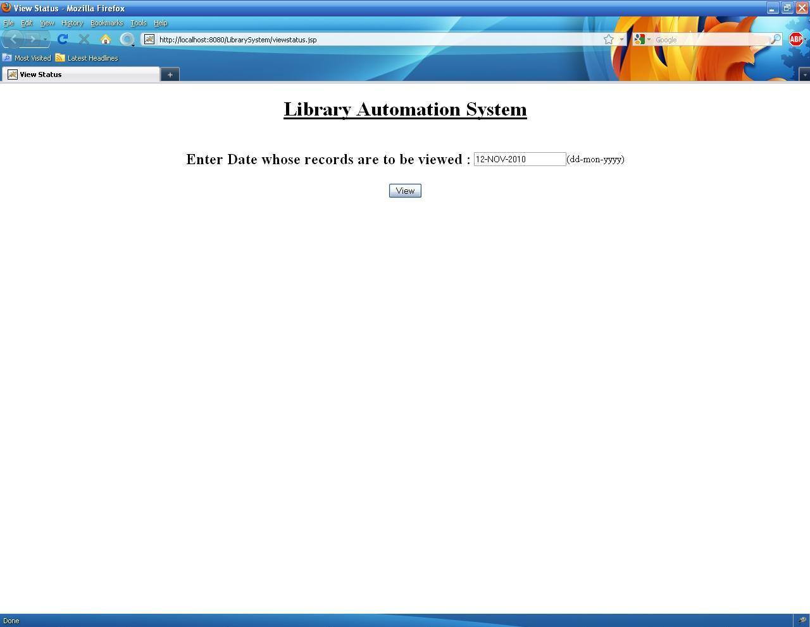
Figure 8: Check Records

CODE SNIPPETS:
As mentioned earlier the code part of the page is contained in a separate java servlet page. Here the connection with the database is made and the values are selected from the database. The connection with the database is done as follows:
Class.forName ("com.mysql.jdbc.Driver");
con=DriverManager.getConnection("jdbc:mysql://localhost:3306/DBName","Root","Password”);
Here con is a connection object. The username and password should be given by the user accordingly. The database name referred here as dbname should also be specified. The values mentioned in the textboxe of the webpage are assigned to local variable with similar names to get the values in them as shown:
String dt= request.getParameter("dt").toString();
Then the connection with the database is made and a statement object is created and the query is executed to insert the values into the database. The following code is used to do it:
s1 = con.createStatement();
String s="select * from checkout where borrow_dt=’”+dt”’”;
Resultset records;
records=s1.executeQuery(s);
Here s1 is the statement object and the string‘s’ is used to create the complete query which is then executed. Here ‘record’ is a Resultset object. This code is used to display the resources checked out on the given date. For the resources which are returned on the same date a similar code is used to display them. The code is as follows:
String s2="select * from checkout where borrow_dt=’”+dt+”’”;
Resultset records2;
Records2=s1.executeQuery(s2);
Here the string‘s2’ is used to create the complete query which is then executed. Here ‘record2’ is a Resultset object. The output of this page is shown in a separate page as shown:
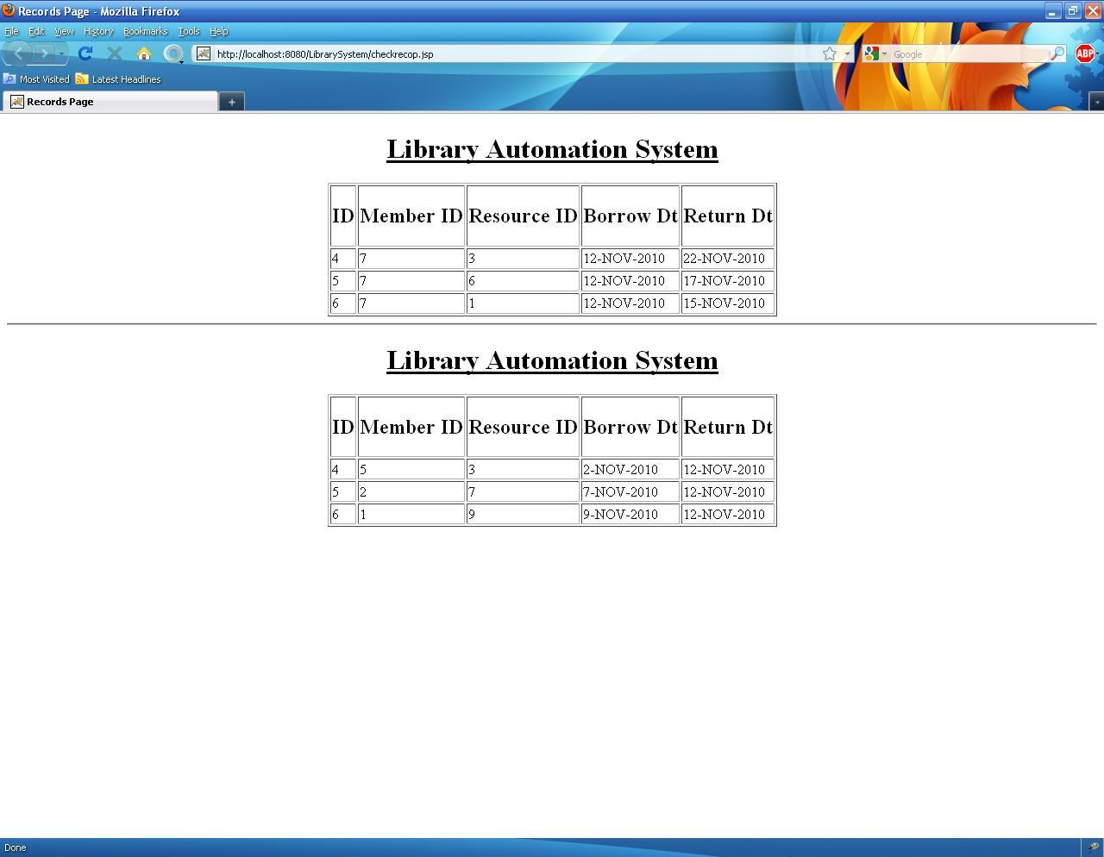
Figure 9: Output of Check Records
Thus the library administrator can view the resources checked out and returned on a given date.
Conclusions
In this case study we model a typical library system fo the 21st century, previously the members of the library or the library manager has to search the index manually to find whether a book is available or not, and even if it is present in the library records , it might be that all the copies of that book might be taken by other members , so at the end a aweful lot of time is wasted without any good work done. To avoid these situations and many other, we transform the library system in to a automated one, where all the data regarding the resources,availibility etc of the library are kept in a centralized database, which can be accessed through user friendly GUI by both members of the library and the library manager. An attempt has been made to make this library system as practically applicable as possiable.

